**Zoom Lecture March 26**

Consider the open loop transfer function of

$$H\left(s\right)=\frac{1}{{\left(s+1\right)}^{3}}$$

root locus

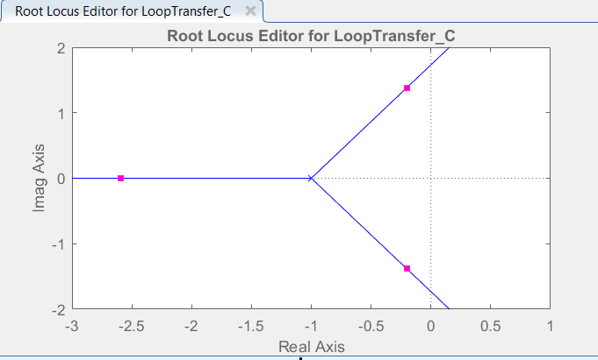

Bode plot – identify gain and phase margins

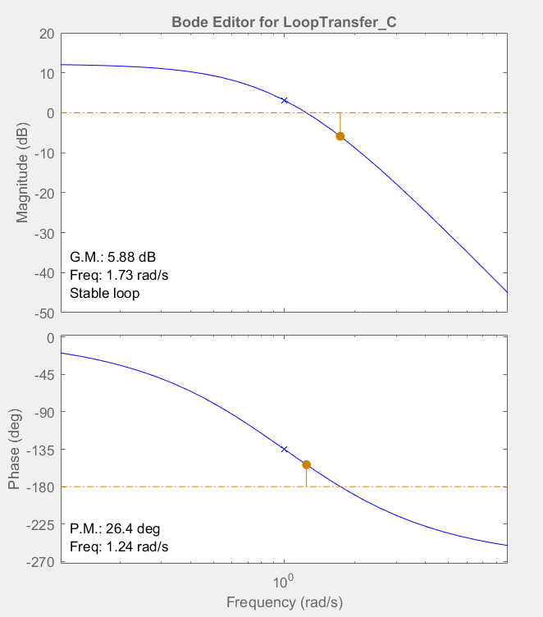

Bode plot useful in showing how much gain and phase in the loop that can be added in.

Ge-sT

H(s)

+

-

R(s)

Y(s)

E(s)

Consider the open loop transfer function of

$$H\left(s\right)=\frac{{\left(s+1\right)}^{2}}{s^{3}}$$

root locus

Type 3 loop which is common in frequency control of oscillators and radar tracking control loops.

sisotool

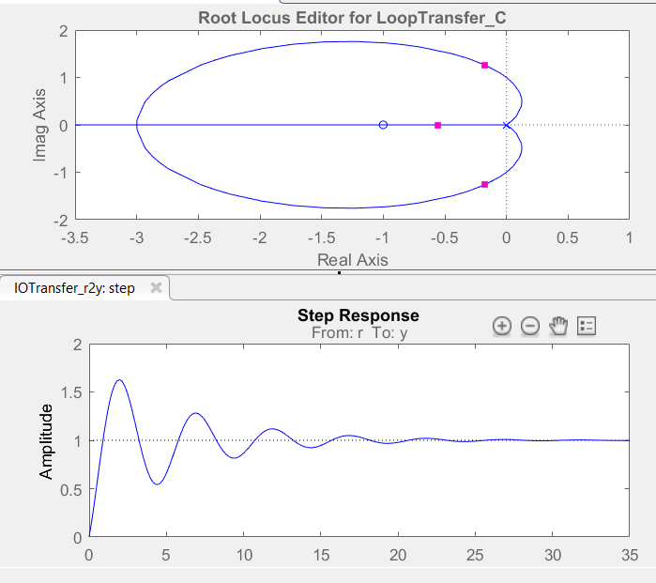

Feedback loop can be stable if the loop gain is greater than certain amount.

bode plot shows inconclusive results



need Nyquist plot to solve this.

Nyquist plot is essentially a plot of the open loop transfer function but in the complex plane. Bode is a plot of phase and magnitude of H(jw) as a function of frequency on separate plots. Nyquist is a plot of the H(jw) in the complex plane and not explicitly a function of frequency.

As with Bode it is useful for determining stability when:

1. H(s) is not in the form of a rational polynomial of s

2. H(s) not known but only measured or simulated at discrete frequencies of jw.

It is more difficult to draw but more powerful in interpretation.

H = zpk([-1,-1],[0,0,0],1);

nyquist(H)

Plot like this



ok how do we get that and what does it mean?

Evaluate H(s) on the contour that includes the RHP steering around any poles on the jw axis.

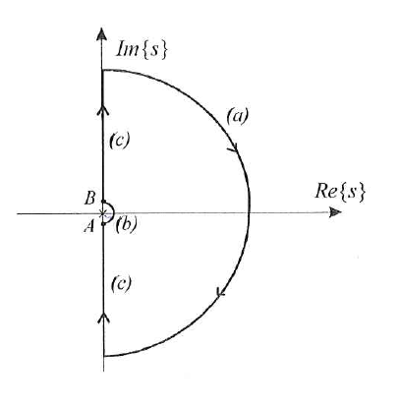

Start with example of

$$H\left(s\right)=\frac{1}{s+1}$$

H = tf(1,[1,1]);

nyquist(H)

